Project Web Data Mining & semantics

Arthur WIRIATH DIA7

_____________________________________________________________________

Summary :

1. How to install
2. How to use and screen shots of functionalities
3. Additional Information and self evaluation

 Github link :

1. How to install

With a zip file :

In order to install the project you need to extract the zip file. At that point a folder name project should be visible. The only remaining step is to open the folder with visual code or any other ide and execute the projet.py file.

 With github :

Go to the place where you want the project folder to be in the cmd or any equivalent then clone the project with the command “git clone ….”. The only remaining step is to open the folder with visual code or any other ide and execute the projet.py file.

1. How to use :

The ontology:

You can explore the ontology on protege 5 (The ontology is not related to the code on python and the sparql queries). Here are some screens :

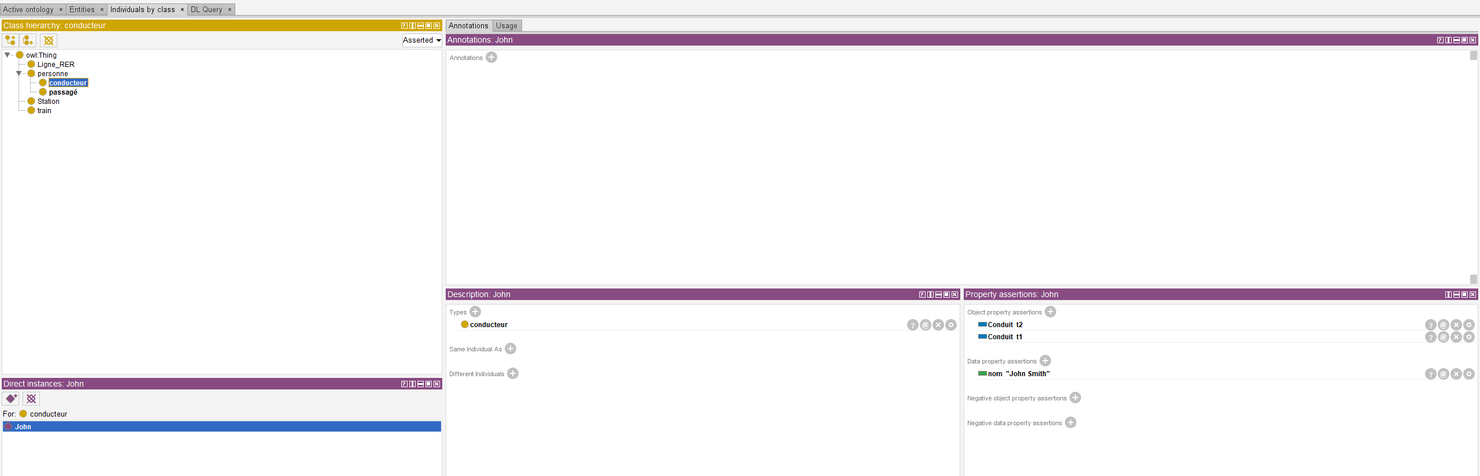

The python script:

To use the python script you can simply execute the project.py file and a user interface should pop up as show on this picture:

Here you can select which query you would like to execute. For instance here is the windows that open if you click on the query : "Affichage des stations qui sont desservie par plusieurs ligne"

1. Additional Information and self evaluation:

Screenshot of the code that convert the api url and the context.json file to json-ld format :

For your information there is a donnée.json file that contain an example of the answer given by the url.

